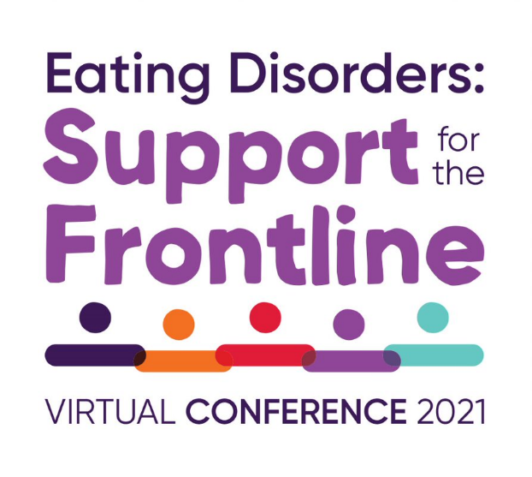
Joining Instructions

Conference: Eating Disorders: Support for the Frontline
Date: 24th and 25th November 2021
Platform: https://events.beateatingdisorders.org.uk/

About the Event
Frontline is designed for family members and for those working with patients on a daily basis. It aims to give those caring for people with eating disorders a place to come together, hear from experts by profession and experience, and learn new skills to help them support those suffering and take care of their own wellbeing.

Format of the Event
This year the conference will take place virtually and we have an exciting programme planned, which has been influenced by those who have experienced caring for a loved one. Sessions will also be recorded, so that you are able to watch content for up to a month after the conference has finished. You can access the recordings using the same link you use to access the conference for live sessions.

Virtual Conference Platform
For the best audience experience we recommend using a laptop or PC to view the conference sessions and to interact however the platform is available on all devices including android, iOS, Windows and Blackberry. To access this platform please enter the following address into your internet browser; https://events.beateatingdisorders.org.uk/

Once you have opened up the platform, add it to your home screen or bookmark it for future use. You will only be able to access the platform with the email address you were registered with. You will need to enter your email address and create a password in order to register onto the platform. The name you enter on registration will be the name that all other attendees can view. If you wish to remain anonymous, please enter an alias. You can also do this via the profile button in the top, right hand corner if you wish to change your name later.
Everything you need for the conference is on the platform, please use this for all links to programmes, workshop and important updates.

Through the platform we have a user guide and frequently asked questions on ‘how to’. There is also live event support that can be contacted throughout the platform to ask questions regarding the platform or event.
You can access conference schedules on the platform and select which session you want to attend to then show in a personal itinerary. You can read session synopses and speaker biographies, make notes on sessions to email to yourself, share photos, tweet and network with fellow delegates.

Any Questions?
If you have any technical issues both before the event or during the conference you can contact the in-Platform Event Support, call the dedicated phone line +44 1275 266003 or contact the administrators through the conference platform or email: conferences@beateatingdisorders.org.uk

We look forward to ‘seeing’ you at the event!

